EXPT NO:3 | CLEANSE DATA BY HANDLING MISSING VALUES, OUTLIERS, AND INCONSISTENCIES USING TABLEAU AND POWERBI
DATE: 10.07.2026

PRE-LAB QUESTIONS (PROVIDE BRIEF ANSWERS TO THE FOLLOWING QUESTIONS)

- What are the potential impacts of missing values in a dataset, and what are some common strategies to address them in Tableau and Power BI?
Missing values can reduce the accuracy of data analysis and may lead to incorrect conclusions. They can also affect charts, calculations, and reports. In Tableau and Power BI, missing values can be handled by removing incomplete records, replacing them with suitable values, or using calculated fields. Choosing the right method depends on the type of data and the analysis required.

- What is the importance of identifying and addressing outliers in a dataset? How can outliers affect data analysis and model performance?

Outliers are data values that are very different from the rest of the dataset. They can distort averages, charts, and statistical results, leading to misleading insights. Identifying outliers helps improve the accuracy of analysis and predictive models. Tableau and Power BI make it easier to detect outliers through visualizations such as box plots and scatter charts.

- What types of data inconsistencies might you encounter during data cleansing, and how can Tableau and Power BI help in resolving them?

Data inconsistencies include duplicate records, incorrect formats, spelling mistakes, and inconsistent date or number formats. These issues can reduce the quality of data and affect analysis. Tableau and Power BI provide tools to clean, transform, and standardize data before creating visualizations. This helps ensure that the data is accurate and consistent.

- How do you identify patterns in data using visualizations to spot missing values, outliers, and inconsistencies?

Visualizations help users quickly identify unusual patterns and data quality issues. Charts such as scatter plots, box plots, and histograms can reveal outliers, while tables and summary views can highlight missing values or inconsistent entries. By exploring these visuals, users can identify problems and clean the data before analysis. This improves the reliability of the results.

- What is the role of calculated fields in data cleansing, and how can they be used to handle missing values and outliers in Tableau/Power BI?
Calculated fields allow users to create new values using formulas based on existing data. They can be used to replace missing values, correct data, or perform calculations without changing the original dataset. They also help identify or limit the effect of outliers during analysis. This makes the data more accurate and useful for reporting and decision-making.
IN-LAB EXERCISE:
OBJECTIVE:
To clean a given dataset (e.g., Superstore Sample in Tableau and Financials/Sales Data in Power BI) by identifying and resolving missing values, outliers, and inconsistencies using built-in tools, ensuring the dataset is accurate and ready for analysis.
PROCEDURE:
  - Open the Tool and Connect Dataset
o Open Tableau Desktop , Power BI Desktop.
    - Load the built-in dataset (Sample - Superstore in Tableau / Financials in Power BI).
    - Preview the dataset to understand its structure.
  - Initial Inspection o Explore fields such as Sales, Profit, Region, or Product Category.
    - Check for nulls, inconsistent text values (e.g., "South Region" vs. "South"), or date formatting issues.
  - Handling Missing Values o Use Data Interpreter (Tableau) / Power Query (Power BI) to highlight nulls. o Replace missing numerical values with mean/median, and text with "Unknown".
    - Use calculated fields: IFNULL([Field], Default) in Tableau or IF(ISBLANK([Field]), "Unknown", [Field]) in Power BI.
  - Detecting and Managing Outliers o Create scatter or box plots for Sales and Profit to identify extreme values.
    - Choose strategies:
      - Filter them temporarily.
      - Apply caps using calculated columns.
      - Flag them with labels for review.
  - Resolving Inconsistencies o Use Group/Alias (Tableau) / Replace Values (Power BI) to standardize text.
    - Normalize data formats, such as date fields or currency units.
- Validation with Visuals
    - Build dashboards with histograms, bar charts, and box plots to visually confirm improvements.
    - Compare before/after cleaning stages for accuracy.
- Save the Cleaned Dataset o Save as .twbx (Tableau) / .pbix (Power BI).
o Optionally export cleaned data to .csv.
- Summary Dashboard
o Create a visual summary of the cleaning process, highlighting:
      - Fields corrected.
      - Nulls/outliers removed or adjusted.
      - Clean dataset metrics (record count, completeness %).

Experiment Dataset:
  - Tableau: Sample - Superstore
  - Power BI: Financials or Sales Data
How to Access:
Tableau:
  - Navigate to: Start Page → Sample Workbooks
  - Or: Help → Sample Data → Open Sample Data Folder
Power BI:
  - Navigate to: Home → Get Data → Excel → Choose sample datasets (e.g., Financial Sample.xlsx)
  - Microsoft also hosts Power BI sample datasets online.
Fields Used:
  - Sales
  - Profit
  - Region
  - Category
  - Order Date / Transaction Date

Power BI
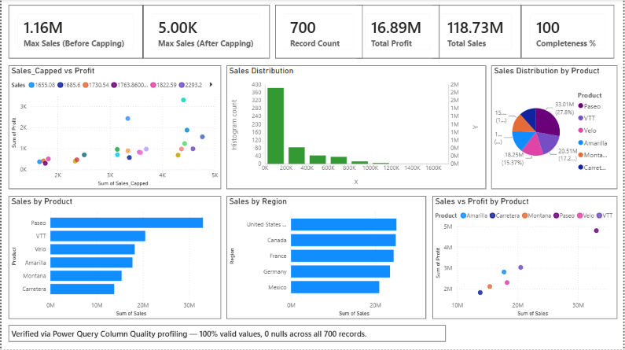

TABLEAU
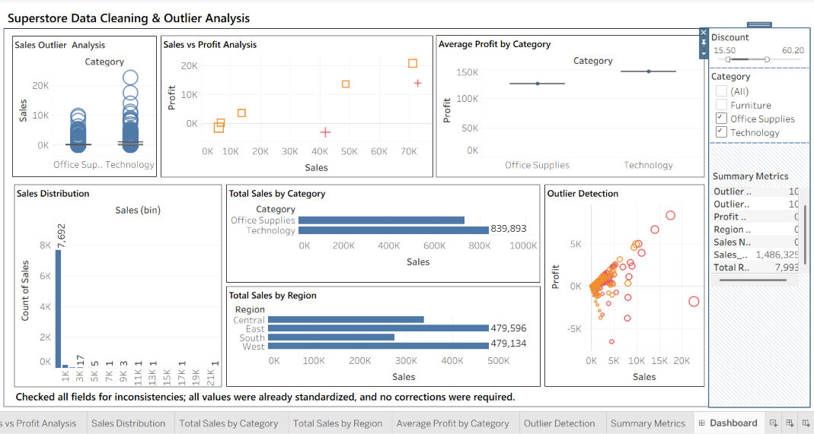

POST-LAB QUESTIONS (PROVIDE BRIEF ANSWERS TO THE FOLLOWING QUESTIONS)
- What method did you use to replace missing values in numeric fields?

I checked the Sales, Profit, and Region fields for nulls using calculated fields like SUM(IIF(ISNULL([Sales]), 1, 0)). Since the Superstore dataset turned out to be already complete, no nulls were found — so no replacement was actually needed. If nulls had shown up, I would've used IFNULL([Field], AVG([Field])) for numeric fields to substitute the average value.

- How were outliers handled in your dataset and what visual confirmed their correction?

I used scatter plots and box plots to identify outliers in the Sales and Profit data. Instead of removing them, I flagged them for review because they may represent genuine business transactions. The scatter plot clearly showed the extreme values separated from the rest of the data. This helped analyze outliers without affecting the original dataset.

- What inconsistencies were detected in categorical values and how were they standardized?

I checked the Region field for inconsistent naming (like "South Region" vs. "South"), which is a common issue mentioned in the lab. In this case, the Region field was already clean — it only had four consistent values: Central, East, South, West. So no grouping or aliasing was required, but I documented this check directly on the dashboard as proof the field was inspected.

- Describe how calculated fields helped in resolving data issues.

Calculated fields were key throughout the process. I used them to count nulls per field, calculate total record counts, flag outliers based on profit thresholds, and compute an overall completeness percentage. This let me turn raw checks into simple, readable numbers (like "Nulls Found: 0" or "Completeness: 100%") instead of manually scanning the dataset row by row.

- How did your dashboard demonstrate the effectiveness of the data cleaning process?
The dashboard combined scatter plots, a histogram, bar charts, and summary metrics to validate the cleaned data. It showed that the dataset had no missing values, consistent categories, and clearly identified outliers. The interactive visuals made it easy to verify the data quality and confirmed that the dataset was ready for analysis.

RESULT:

The dataset was successfully cleaned and prepared for accurate analysis using Tableau and Power BI. Issues such as nulls, inconsistencies, and outliers were identified and resolved, improving data quality significantly.

ASSESSMENT

Description |  | Max Marks | Marks Awarded
Pre Lab Exercise |  | 5
In Lab Exercise |  | 10
Post Lab Exercise |  | 5
Viva |  | 10
 | Total | 30
 |  | Faculty Signature

